**Assignment-3**

**EXPERIMENT – 4: Write a program to sort values in Ascending / Increasing order using Shell Sort technique in linear array.**

#include<stdio.h>

void shellsort(int a[],int n);

int main()

{

int a[50],i,n;

printf("Enter the size of array:");

scanf("%d",&n);

printf("\nEnter the elements of the array:\n");

for(i=0;i<n;++i)

scanf("%d",&a[i]);

shellsort(a,n);

return 0;

}

void shellsort(int a[],int n)

{

int gap,i,j,temp;

for(gap=n/2;gap>0;gap/=2)

{

for(i=gap;i<n;i++)

{

temp=a[i];

for(j=i;j>=gap&&a[j-gap]>temp;j-=gap)

a[j]=a[j-gap];

a[j]=temp;

}

}

printf("\n\nSorting in Ascending Order:\n");

for(i=0;i<n;++i)

printf("%d ",a[i]);

for(gap=n/2;gap>0;gap/=2)

{

for(i=gap;i<n;i++)

{

temp=a[i];

for(j=i;j>=gap&&a[j-gap]<temp;j-=gap)

a[j]=a[j-gap];

a[j]=temp;

}

} printf("\n\nSorting in Descending Order:\n");

for(i=0;i<n;++i)

printf("%d ",a[i]);

}

**OUTPUT-**

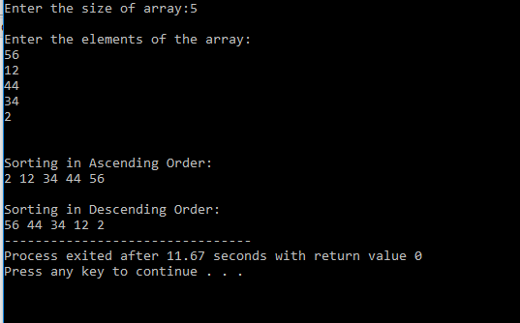

**EXPERIMENT – 5: Write a program to sort values in Ascending / Increasing order using Insertion Sort technique in linear array.**

#include <stdio.h>

#include<conio.h>

int main()

{

int a[100],n,i,j;

printf("Enter the size of array:");

scanf("%d",&n);

printf("\nEnter the elements of the array:\n");

for(i=0;i<n;i++)

{

scanf("%d",&a[i]);

}

for (int i = 0; i < n; i++)

{

for (int j = 0; j < n; j++)

{

if (a[j] > a[i])

{

int tmp = a[i];

a[i] = a[j];

a[j] = tmp;

}

}

}

printf("\n\nSorting in Ascending Order:");

for (int i = 0; i < n; i++)

{

printf(" %d ", a[i]);

}

for (int i = 0; i < n; i++)

{

for (int j = 0; j < n; j++)

{

if (a[j] < a[i])

{

int tmp = a[i];

a[i] = a[j];

a[j] = tmp;

}

}

}

printf("\n\nSorting in Descending Order:");

for (int i = 0; i < n; i++)

{

printf(" %d ", a[i]);

}

return 0;

getch();

}

**OUTPUT-**

